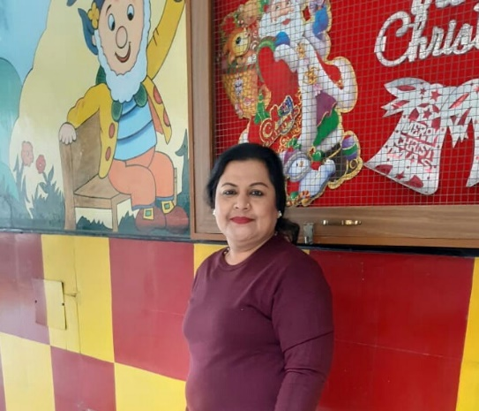

You’ve probably heard it more times than you can count – and said a time or two yourself – kids don’t come with instructions. The best you can do is love them, try your hardest to make the tough choices that you think are right for them, and defer to those who know better than you do when you’re in over your head. Sometimes, that might be your trusted pediatrician, while other times you’ll likely find yourself turning to other parents with a few more years of experience under their belts who have successfully navigated similar challenges.
Children are very critical and imperative for deciding how the world is going to be in the future. Parenting forms an important aspect for the growth of children. The futuristic heroes need your guidance to be powerful and happier during their later ages.

Bandana Sagar
Kindergarten Teacher

